# COMP489 TME2 - Michael Wong 310 1126

IDL file can be found in 489 TME2/src/tme2.idl  
Source files can be found in 489 TME2/src/TME2/

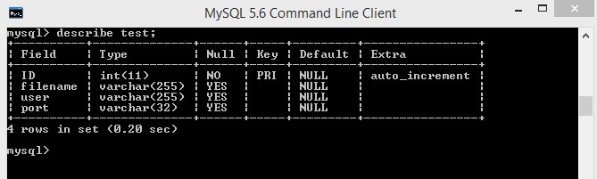

MySQL table ‘test’ used for testing in this assignment.

**Test:**

**Register a file onto the mysql database using the client.**

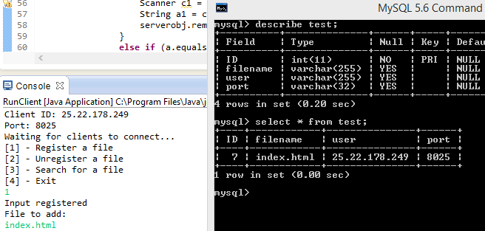

Expected: index.html should be registered as the filename along with the user and port.

Actual: success

**Test: Delete a file from the database owned by the client using the client.**

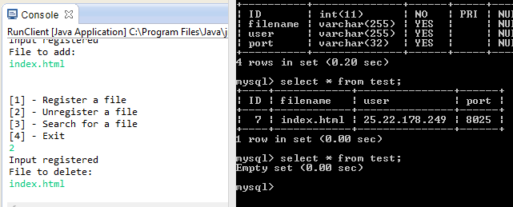

Expected: index.html is removed leaving an empty set

Actual: success

**Test: First insert a file onto the database then search for the file on the database through the client.**

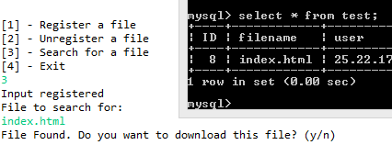

Expected: the client should be able to find the file.

Actual: success

**Test: Search for a file that does not exist in database and return fail.**

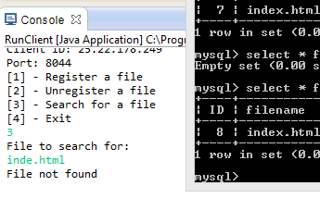

Expected: file not found, and exit loop

Actual: success

**Test: Search for then download a file from another client. The file ../index.html contains “hello”. To replicate this test, register a file path in one client, then search for this path in another client.**

**MySQ10L:**

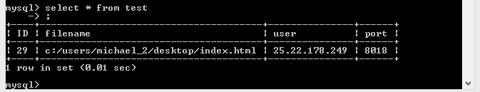

**Client 1:** (listening on 25.22.178.249:8018)

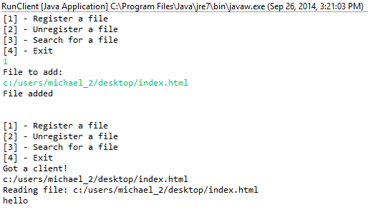

**Client 2:** (listening on 25.22.178.249:8093)

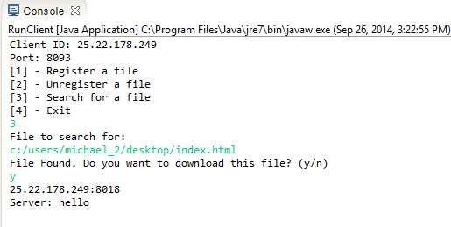

Expected: Client 1 receives the filename from Client 2 then reads the file into the socket for Client2.  
Actual: Success